A Mini Project with Seminar
ON

A Comparative Study of ML Models for Tumor Classification

Submitted in partial fulfillment of the requirements for the award of the

Bachelor of Technology
in

Computer Science and Engineering (Data science)
by

M. Isaac Manohar | 23241A6741
B. Sai Shiva Reddy | 23241A6704
K. Vishnu Vardhan | 23241A6733

Under the Esteemed guidance of

Dr. Aruna Kumari

Associate Professor
Department of Data Science

GOKARAJU RANGARAJU INSTITUTE OF ENGINEERING AND TECHNOLOGY
(Approved by AICTE, Autonomous under JNTUH, Hyderabad)
Bachupally, Kukatpally, Hyderabad-500090
2025-2026

i


GOKARAJU RANGARAJU INSTITUTE OF ENGINEERING AND TECHNOLOGY
(Autonomous)

Hyderabad-500090

CERTIFICATE

This is to certify that the Mini Project with Seminar entitled “A Comparative Study of ML Models for Tumor Classification” is submitted by M. Isaac Manohar (23241A6741), B. Sai Shiva Reddy (23241A6704) and K. Vishnu Vardhan (23241A6733) in partial fulfillment of the award of degree in BACHELOR OF TECHNOLOGY in Computer Science and Engineering (Data science) during Academic year 2025-2026.

Internal Guide | Head of the Department
Dr. Aruna Kumari | Dr. S. Govinda Rao
External Examiner

ii

ACKNOWLEDGEMENT

There are many people who helped us directly and indirectly to complete our project successfully. We would like to take this opportunity to thank one and all. First, we would like to express our deep gratitude towards our internal guide Dr. Aruna Kumari, Associate Professor, Department of Computer Science and Engineering (Data Science), for her support in the completion of our dissertation. We are thankful to our major project coordinators Mr. K. Mallikarjuna Raju, Assistant Professor and Ms. Srilatha, Assistant Professor, for there valuable suggestions and comments during this project period.
We wish to express our sincere thanks to Dr. S. Govinda Rao, Head of the Department, and to our principal Dr. J. Praveen, for providing the facilities to complete the dissertation. We would like to thank all our faculty and friends for their help and constructive criticism during the project period. Finally, we are very much indebted to our parents for their moral support and encouragement to achieve goals.

M. Isaac Manohar (23241A6741)
B. Sai Shiva Reddy (23241A6704)
K. Vishnu Vardhan (23241A6733)

iii
DECLARATION

We hereby declare that the major project titled “A Comparative Study of ML Models for Tumor Classification” is the work done during the period from 18th December 2025 to 16th April 2026 and is submitted in the partial fulfillment of the requirements for the award of degree of Bachelor of Technology in Computer Science and Engineering (Data science) from Gokaraju Rangaraju Institute of Engineering and Technology (Autonomous under Jawaharlal Nehru Technology University, Hyderabad). The results embodied in this project have not been submitted to any other University or Institution for the award of any degree or diploma.

M. Isaac Manohar (23241A6741)
B. Sai Shiva Reddy (23241A6704)
K. Vishnu Vardhan (23241A6733)

iv

ABSTRACT

This project involves comparing the ML models to classify tumors with an objective to advance the dependability and accuracy of medical diagnosis. Studies involve processing database and medical data, feature of interest recognition, and various ML models, such as SVM and RF. A fundamental area of interest of the project is the Model Optimization Module whereby hyperparameter optimization is done by performing a grid search on the model to maximize performance by optimising the model parameters like SVM kernels and RF estimators. Performance of the model is examined with both tuned and untuned models in order to understand the ways of learning optimization. Moreover, a comprehensive Performance Evaluation Layer will be implemented in which the, Precision, Accuracy, Recall, and the F1 Score measures, implemented to establish performance of the ML models. The FPFN can be calculated using some kind of instruments like Confusion Matrix, but the ROC Curves and AUC are needed to prove that the constructed model is capable of classifying data in the sphere of health care. Overall, considering the findings obtained during the research, it should be stated that models which have been well optimized work more efficiently than those that haven’t been optimized at all. That is why the presented project has proved that it is necessary to optimize a model to create a good tumor classifier.

v

LIST OF FIGURES

Figure Number | Name of the Figure | Page Number
1.1.1  3.1.1  3.2.1  3.2.2  3.2.3  3.2.4  4.2.1  4.2.2  4.2.3 | Architecture Diagram  Module Connectivity Diagram  UML Illustration  Sequence Diagram  Use Case Diagram  Activity Diagram  Dashboard  Ultrasound Analysis  Model Analysis | 06  18  21  23  25  27  32  33  34

vi
LIST OF TABLES

Table Number | Name of Table | Page Number
1.1 | Machine Learning Models Used | 8
1.2  2.1  3.4 | Evaluation Metrics  Summary of Literature Survey  Software and Hardware Requirements | 9  13  29

vii

LIST OF ACRONYMS

- Support Vector Machine (SVM)
- K-Nearest Neighbours (KNN)
- Random Forest (RF)
- Decision Tree (DT)
- Logistic Regression (LR)
- Convolutional Neural Network (CNN)
- Principal Component Analysis (PCA)
- Extreme Gradient Boosting (XGBoost)
- Magnetic Resonance Imaging (MRI)
- Computed Tomography (CT)
- Breast Ultrasound Images (BUSI)
- Picture Archiving and Communication Systems (PACS)
- Electronic Health Records (EHR)
- Shapley Additive Explanations (SHAP)
- Local Interpretable Model-agnostic Explanations (LIME)

viii

TABLE OF THE CONTENTS

Chapter No. | Chapter Name | Page Number
 | Title | i
 | Certificate | ii
 | Acknowledgement | iii
 | Declaration | iv
 | Abstract | v
 | List of Figures | vi
 | List of Tables | vii
 | List of Acronyms | viii
1. | INTRODUCTION  1.1 Background and Context  1.2 Problem Statement  1.3 Purpose and Objectives of the Proposed  Work  1.4 Scope of the Proposed Work  1.5 Methodology and Approach  1.6 Organization of the Project Report | 1
2 | LITERATURE SURVEY  2.1 Summary of Existing approaches  2.2 Summary: Drawback of Existing Approaches | 10
3 | PROPOSED METHOD  3.1 Modules in the Proposed Work  3.2 Analysis and Design through UML  3.3 Requirements Engineering (of your project)  3.4 Software and Hardware Requirements | 16
4 | RESULTS AND DISCUSSIONS  4.1 Description about Dataset  4.2 Detailed explanation about the  Experimental Results  4.3 Significance of the Proposed Work with its  Advantages  4.3 Limitations of the Proposed Work with its  drawbacks | 31
5 | CONCLUSION AND FUTURE  ENHANCEMENTS  5.1 Conclusion  5.2 Future Enhancements | 39
6 | REFERENCES | 43
7 | APPENDICES | 45

CHAPTER 1

INTRODUCTION

1.1 Background and Context
It should be noted that rapid advancements in the field of health technology have led to increased precision in diagnoses and patient care. Machine learning (ML) is one such innovation that can be applied for analyzing medical information. One of the most significant uses of ML is tumor classification because early cancer detection can significantly increase the survival rate and treatment outcomes.
A tumor refers to an irregular increase of cells which can either be benign or malignant. Benign tumor is non-cancerous and it does not spread whereas malignant tumor is cancerous and can invade surrounding tissues and spread or metastasize to other body parts. Correct differentiation between the two types is essential in the establishment of the proper treatment plans.
The conventional methods of diagnosis involve the use of radiologists and pathologists to read medical images like MRI, CT scans, and biopsy samples. But there are some drawbacks to such approaches, which include human errors, subjectivity, and limited time. In light of the increasing availability of information regarding medical procedures, there is a need for computer-based techniques that help make decisions. As a result, computer-based decision making will emerge sooner or later.
ML algorithms can handle huge amount of data and find patterns or even make predictions with great accuracy. Many machine learning algorithms such as Support Vector Machines, Random Forest, Decision Trees, and KNN algorithms have been used previously for tumor classification tasks. The current research attempts to apply the findings from previous literature and assess machine learning models.
Further, the application of machine learning in the classification of tumors does not only enhance the accuracy of the diagnosis process, but also supports the decision-making process through the provision of information that is driven by data. With the increase in the availability of data in the medical field, coupled with the increasing computational capabilities of computers to facilitate this process, machine learning models can undergo continuous training and optimization processes such as hyperparameter tuning. This way, the model will identify certain patterns and associations that would otherwise be difficult to detect by human beings.
1.2 Problem Statement
It is essential that the cancer is diagnosed accurately and at the right time because only then will the cancer treatment process prove to be successful and result in patient survival. The manual methods employed by the traditional diagnostic system depend on human labour in the processing of medical data and can be very slow. As medical data set keeps growing, the repeating pattern of intricate and efficient analysis of tumor features has been complicated. Despite the popularity of Machine Learning methods to detect tumors, most of them are studied in small models and do not involve a systematic comparison under standardized conditions. Consequently, an automated and systematic framework that analyses several ML algorithms and chooses the most trustworthy model to classify tumors is necessary in order to help medical decision-making.
The classification of tumor is a complex procedure because of various factors that is influencing the reliability and the accuracy of tumor diagnosis. Among few of the major problems are:
High Dimensional Data: Medical data typically have a lot of features, and it can be challenging to know the most significant features.
Data Imbalance: In most datasets, the percentage of malignant cases is much less important, the percentage of benign cases is much larger, thus contributing to biased predictions.
Difference in Tumor Characteristics: Tumor sizes, shapes, texture and location vary and thus it is complicated to classify.
Noise and Missing Data: Medical data can have missing or noisy data that can impact the model performance.
Reliance on Expert Knowledge: Traditional approaches highly depend on domain experts, and this is not always the case.
Because of these issues, multiple machine learning models need to be assessed and the one that enhances the best results under the particular conditions identified. This project solves this issue by comparing different ML algorithms on standardized evaluation metrics.

1.3 Aim and goal of the proposed work
Purpose
This project is mainly aimed at creating an effective and successful mechanism of classifying tumors with the help of ML. The experiment targets to compare various ML algo to find out their efficacy when categorizing tumors as benign or malignant. Through the use of computational intelligence, the proposed system will decrease human reliance in diagnosis and will help the medical workers make decisions faster and more intelligently.
Moreover, this work focuses on enhancing diagnostic accuracy by using preprocessing techniques, feature selection techniques, and model optimization techniques. The system is developed to process complex medical data and outliers meaningful patterns that will be used to classify data accurately. The comparative analysis also contributes to the realization of the best model to be used in various conditions, and then offer useful insights in future studies and practical use.
Objectives
To produce and test the ML algorithms, used here such as K-Nearest Neighbors (KNN), Logistic Regression, Decision Tree, Support Vector Machine (SVM), and Random Forest for the classification of the tumors.
To normalize tumor dataset features to get the features they have to be used to preprocess and standardize the features of the dataset so that model evaluation can be fair and consistent.
To analyze the performance of a model based on different measures like Precision, Accuracy, Recall and F1 Score on overall evaluation.
To compare behavior of model averaging in terms of computational efficiency, stability and overfitting when the experiment is the same.
To determine the most trustworthy and effective ML algorithm to separate benign and malignant tumors.
The project goals is divided into the following: teenage, analytical and performance-based:
Technical Objectives
To obtain and pre-treat tumor-related data to process the missing values, noise, and inconsistencies.
To apply the different ML models, including, Logistic Regression SVM, Decision Tree, Random Forest, KNN and Naive Bayes.
To apply feature normalization and selection to optimize performance of the model.
To divide data into training and testing sample to assess it appropriately.
Analytical Objectives
To have a comparison of the performances of various machine learning models using same data.
To examine the importance of the feature selection and preprocessing on performance of the model.
To analyze the advantages and disadvantages of all the algorithms.
To discover trends within the output of the classifications.
Performance Based Objectives
To compare different models based on performance metrics such as accuracy,
precision, recall, and F1 score.
To compare tuned versus untuned model to evaluate improvement.
To select the most real model with quantitative results.
Expected Outcomes
Determination of the best and most trustworthy machine learning model to classify tumors.
Better insight into the performance of various algorithms with medical data.
A flexible and adaptable architecture to improve medical diagnosis systems in the future.

1.4 Scope of the Proposed Work Revised
The scope of this project is to determines what the project will cover and what it will not cover when we use machine learning methods to classify tumors.

Inclusions:
We will use machine learning models such as Logistic Regression, Support Vector Machines (SVM), Decision Trees, Random Forest, KNN and Naive Bayes algorithms for tumor classification using machine learning techniques.
We will use datasets that are based on MRI images to extract features and classify them using machine learning methods.
We will make sure the data is good to use by doing things like making all the numbers dealing with missing values and making sure the features are on the same scale.
We will take the data from the MRI images and turn it into numbers that a computer can understand using medical imaging data feature extraction technique to transform visual data to numerical data.
We will compare how well different machine learning models work on the data to classify tumors by machine learning methods.
We will use measures, like how accurate the models are, how precise they are, how well they remember things and something called the F1-score to see how well the models are doing to assess the performance of the machine learning models.

Exclusions:
We will not use learning models that can look at MRI images without any help to classify tumors by machine learning methods like something called Convolutional Neural Networks or CNNs.
We will not try to use the project in a real hospital setting or connect it to hospital systems to classify tumors by machine learning methods.
We will not use complicated Deep Learning (DL) models that need a portion of power to run to classify tumors by machine learning methods like things called ResNet or VGG.
We will not try to connect the project to devices that can monitor peoples health using something called the Internet of Things or IoT to classify tumors by machine learning methods.

1.5 Methodology and Approach
The proposed system is systematic and is based on a structured approach to carry out tumor classification through ML in the proposed system. The technique entails several steps beginning with data collection up to the ultimate model analysis and comparison.
In-depth Methodology description.

Architecture Diagram

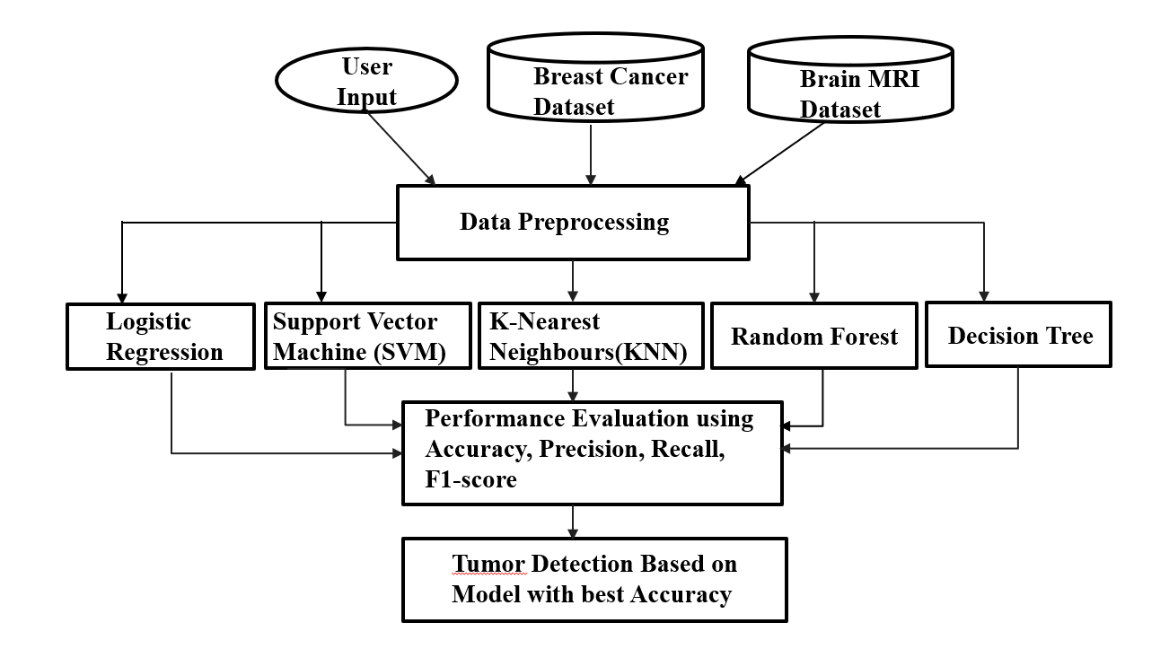
Fig 1.1 Architecture Diagram
1. Dataset Collection
The data in this project is based on MRI (Magnetic Resonance Imaging) images of tumors. These images have visual data concerning the tumor characteristics in terms of size, shape, and texture.

2. Image Preprocessing
Priority to the extraction of features, MRI images are preprocessed to enhance quality and consistency:
Filtering to remove noise.
Image normalization and image resizing.
Development of contrast to improve visibility.
Removal of irrelevant background information
This is done to make sure that the images are extractable to features.

3. Feature Extraction
The following step is the feature extraction in which the relevant information is extracted out of the MRI images and transformed into numbers.
Features extracted can be:
There are texture characteristics (e.g. contrast, homogeneity)
Change in shape (e.g. area, perimeter)
Intensity features (pixel values)
These characteristics are the tumor characteristics in a tabular form.

4. Dataset Formation
Once the features are extracted, then the data can be structured into a structured dataset:
The rows correspond to individual samples (patients/images).
Columns represent extracted features
Target variable: Tumor type (Benign or Malignant)
It is then trained in machine learning models with this dataset.

5. ML Preprocessing (ML Stage)
The formatted data is further preprocessed:
Handling missing values
Feature scaling (Normalization or Standardization)
Elimination of unnecessary or insignificant features.
This enhances model performance and accuracy.

6. Train-Test Split
The dataset is then split into:
Training set (e.g. 80%) to train models.
Test set (e.g. 20%) which is used to test models.
This guarantees fair evaluation of performance.
7. Model Training
Multiple machine learning models are trained on the dataset:
Logistic Regression
Support Vector Machine (SVM)
Decision Tree
Random Forest
K Nearest Neighbours (KNN)
Naive Bayes
Both models acquire patterns using the data to categorize tumors.

8. Hyperparameter Tuning
GridSearch CV is used to tune hyperparameters in order to enhance model performance:
Optimizes parameters such as SVM kernel and C value.
Changes number of trees in Random Forest.

9. Model Evaluation
The results of every model are measured in terms of common indicators:
Accuracy
Precision
Recall
F1-Score
Table 1.1: Machine Learning Models Used

S.NO | Model | Advantages | Limitations
1 | Logistic Regression | Simple and fast | Limited to linear data
2 | SVM | High accuracy | Computationally expensive
3 | Decision Tree | Easy to interpret | Overfitting
4 | Random Forest | High accuracy & robust | Complex model
5 | KNN | Simple implementation | Slow for large datasets
6 | Naïve Bayes | Fast and efficient | Assumes independence

Table 1.2: Evaluation Metrics

Metric | Formula | Significance
Accuracy | (TP + TN) / (TP + TN + FP + FN) | Overall correctness
Precision | TP / (TP + FP) | Reliability of positive predictions
Recall | TP / (TP + FN) | Ability to detect actual positives
F1-Score | 2PR / (P + R) | Balance between precision & recall

CHAPTER 2

LITERATURE SURVEY

2.1 Overview of the Current Methodologies.

Machine learning has become a prominent focus of tumor classification over the previous few years because of the advancement of medical imaging and computational mechanisms. The current literature (2022 and later) is concerned with the optimization of the classification error through the incorporation of feature extraction, and sophisticated ML algorithms.
A number of researchers have used Support Vector Machine (SVM) for the classification of tumors based on MRI-based features. The methods are very precise, particularly in conjunction with feature selection techniques plus Principal Component Analysis (PCA). The performance of SVM, however, requires appropriate parameter tuning.
The recent publications also indicate the usefulness of Random Forest algorithms that are more generalized and robust. These architectures are effective at working with complex data and in avoiding overfitting with ensemble learning algorithms.
K-Nearest Neighbors (KNN) has been applied in certain works because of its simplicity and appropriateness with small to medium size datasets. Nonetheless, recent studies have shown that KNN is computationally infeasible with large datasets.
Lightweight systems have also used naive bayes classifiers in cases where computational efficiency is needed. Fast but with relatively lower accuracy because of independence assumptions, these models are used.
The use of hybrid models, with feature extraction mixed with optimization of machine learning algorithms, is also considered a recent development (2022-2024). These composite models have demonstrated better performance than the single models.
Deep learning methods like CNNs have been studied to directly classify images. These models are highly accurate but have high computation and data requirements, which is why they cannot be used on smaller scale projects.
In general, the recent studies indicate that the most optimal combination of feature extraction and optimized ML models can be used to achieve the finest results in tumor classification problems.

Medical Diagnosis using Logistic Regression (2023)
  - Binary tumor classification with the assistance of Logistic Regression.
  - Is a linear model of base.
  - Gives coefficients of features that are interpretable.
  - Moderate accuracy on structured data.
  - Works with linearly separable data.
  - low performance in nonlinear (complex) patterns.

K Nearest Neighbours in Tumor Classification (2023)
- Uses distance-based learning to predict tumors.
- Non-parametric and simple approach.
- Works on small and clean datasets.
- Accuracy requires optimum K selection.
- Sensitive to feature scaling.
- Slow prediction on large datasets.

Cancer Detection using Support Vector Machine (2023).
  - SVM is used with high dimensional tumor data.
  - Successful in dealing with multifaceted decision frontiers.
  - Has high accuracy with an appropriate choice of kernel.
  - Needs sensitive hyperparameter tuning.
  - Cost to compute is directly proportionate to the magnitude of the dataset.

Machine Learning Methods of Brain Tumor Classification (2023)
  - Compares MRI features on classical ML models.
  - SVM presented stable and consistent results.
  - Emphasizes importance of preprocessing.
- Limited data size impacts generalization.
- Feature extraction through usage of texture, shape.

Random Forest-Based Tumor Prediction Model (2024)
  - Uses ensemble learning to classify tumors.
  - Eliminates overfitting that is found with Decision Tree.
  - Has high precision and recall.
  - Processes high-dimensional features.
  - Not as interpretable as simple models.

Deep Learning Brain Tumor Classification (2024).
  - Uses Convolutional Neural Networks .
  - Automatically extracts features from MRI images.
  - More precise than the traditional ML models.
  - Needs voluminous annotated image datasets.
- High computational and GPU needs.

Analysis of Ml Algorithms for Breast Cancer Diagnostics (2024)
  - Utilizes various assessment tools.
  - Random Forest had the best overall performance.
  - Shows significance of model comparison.
  - Limited hyperparameter optimization

Comparison of ML and DL models in cancer (2024)
- Evaluates both classical ML and deep learning approaches.
- Precision, Accuracy, Recall and, F1-score.
- Deep learning works well with big data.
- Fails to normalize the preprocessing between models.

Deep Learning and Hybrid ML Models to detect tumors (2025).
- Integrates deep learning features with ML classifiers.
- Increases the quality of classification in general.
- Uses feature fusion techniques.
- Enhances generalization capability.
- Increases model complexity.

Explainable AI in Medical Tumour Classification (2025)
  - Combinates explainable AI with tumor classifiers.
  - Gives interpretation of model predictions.
  - Enhances the confidence in AI-based medical systems.
  - Has competitive classification performance.
  - Introduces complexity in computation and implementation
Table 2.1. Summary of Literature Survey
Ref No & Year | Methodology | Dataset Name | Result | Advantages | Drawbacks
[1] 2023 | Supervised ML (SVM, Random Forest) | Breast Cancer Dataset | ~95% Accuracy | Stable performance, easy implementation | Limited dataset size
[2] 2023 | Comparative ML (RF, DT, KNN) | Cancer datasets | ~94% F1-score | Identifies best-performing model | Basic hyperparameter tuning
[3] 2023 | SVM (RBF Kernel) | Tumour classification dataset | ~96% Accuracy | Handles high-dimensional data well | Requires parameter tuning
[4] 2024 | Random Forest (Ensemble Learning) | Medical imaging dataset | Recall > 95% | Robust and reduces overfitting | Less interpretable
[5] 2024 | KNN (Distance-based learning) | Small medical datasets | ~93% Accuracy | Simple and easy to implement | Slow on large datasets
[6] 2024 | CNN-based Deep Learning | Brain Tumour MRI Dataset | ~98% Accuracy | Automatic feature extraction | High computational cost
[7] 2024 | Feature Selection + ML (PCA) | Medical diagnosis dataset | Improved F1-score | Reduces complexity | May remove useful features
[8] 2025 | Hybrid Model (CNN + RF) | Multi-source dataset | ~97% Accuracy | Better generalization | Complex architecture
[9] 2025 | Explainable AI (SHAP, LIME + ML) | Tumour datasets | High interpretability | Transparent decision-making | Extra computation required
[10] 2025 | ML vs DL Comparative Study | Oncology datasets | Balanced Accuracy/Precision/Recall | Shows DL better for images | No standardized preprocessing

2.2 Summary: Drawbacks of Existing Approaches
- Although machine learning methods have led to a big advancement in classification of tumors, a number of constraints are noted in the current methods.
- Most of the papers are devoted to the implementation of a single or two machine learning algorithms instead of a comparative analysis of them. This reduces the knowledge of the performance of various models under identical conditions and it is hard to determine which algorithm is the most reliable.
- The other significant weakness is that various scientific studies assess the performance of models mainly through accuracy. In medical diagnosis, accuracy is not a sufficient metric, because other metrics like precision, recall, and F1-score are as well, particularly in reducing false negatives in detecting malignant tumor.
- Deep learning-based methods are highly accurate but need huge annotated datasets and substantial amounts of computing power. That renders them not so useful to small-scale projects or resource-limited environments. Moreover, such models tend to be black-box systems making them less interpretable.
- Most of the existing research relies on manual model selection and hyperparameter tuning, which is subject to domain knowledge and makes implementation more complex. The unfair comparison and unreliable results also result because of inconsistent preprocessing methods in different models.
- The second constraint is the inability to focus on the accuracy, interpretability and computational efficiency. There are models that have high accuracy but hard to interpret, a critical consideration in medical use.
- In addition, some studies do not test the generalization ability of models after they have been tested on small sets of data. This compromises the accuracy of the models in the real world situation.
- Lastly, the absence of a standardized and organized system that compares various machine learning models on the same preprocessing and evaluation terms is also lacking. This leaves a vacuum of coming up with the most effective and reliable model to classify tumors.

Research Gaps:
- A significant number of studies apply single or fewer ML algorithms, without a general comparative study.
- Most studies rely on manual model selection and hyperparameter optimization, which rely on time and expertise.
- Some of the works consider only accuracy to assess models, and other significant metrics such as Precision, Accuray, Recall, and F1-score are neglected.
- Many models are only tested on small or specific datasets, which restricts real-world generalization.
- The Deep Learning (DL) methods are resource-intensive in the terms of both data and computing power, and might not be feasible in all locations.
- The drawback is that little attention is paid to such a balance between accuracy, computational efficiency, and model interpretability in medical diagnosis.
- The number of studies that compare ML models in the same conditions systematically is low.

CHAPTER 3

PROPOSED METHOD

3.1 Modules in Proposed Work
The proposed system is broken down into several modules with each module carrying out a particular task in the tumor classification pipeline. This modular design makes it transparent, scalable, and efficient to process medical data. The major modules in the system are the following:
Data Collection and Pre-processing Module
This component will be the in charge of obtaining and processing the tumor data to be analyzed further. The dataset is Breast Cancer Wisconsin dataset that includes structured numerical features of tumors.
The module cleanses the data by filling in the missing values as well as dropping irrelevant attributes. It will also standardize all features with StandardScaler to get all features on the same scale. The dataset is also divided into training set and testing set based on stratified selection to ensure that the classes are balanced.
Module of Feature Engineering and Transformation.
The module is about transforming input features to the appropriate format to be used by machine learning models. It makes certain that every feature is standardized and without inconsistencies.
Scaling of features is used to enhance performance of the model, particularly, distance-based algorithms such as KNN and margin-based models such as SVM. The module also prepares the feature array (X) and target variable (y) to be efficiently trained and evaluated.
Model Training Module
The Model Training Module uses several supervised machine learning algorithms to classify tumors.
The models which are used in this project are Logistic Regression, Support Vector Machine (SVM), K-Nearest Neighbors (KNN), Decision Tree, and Random Forest. All the above-mentioned models are trained on the same preprocessed dataset to compare them on equal terms. This module allows determining the weaknesses and strengths of various algorithms.
Validation and Optimization Module.
The module will boost the performance and reliability of the ML model by using validation and tuning.
It applies 5-fold cross-validation to make sure that the performance is similar in the various data splits. GridSearchCV is used to optimize model hyperparameters, including SVM kernel type, regularization strength and tree count in Random Forest, through hyperparameter tuning. This assists in minimizing overfitting and enhancing generalization.
Performance Evaluation Module
This module measures the trained models on several performance metrics to have a comprehensive measurement.
Measures like Precision, Accuracy, Recall and F1-Score are calculated. The Confusion Matrix is created to examine the classification errors, especially false negatives in the detection of malignant tumor. Also, the ROC-AUC scores are used to assess the capacity of the model to differentiate between classes.
Error Analysis Module
This module discusses misclassifications of the models in order to learn their limitations.
False negatives are also considered with special attention given to them as they are malignant tumors that have been wrongly diagnosed as benign. The module analyzes situations in which values of features are similar or ambiguous patterns to enhance the effectiveness of the model selection and reliability.
Interpretability Module
Interpretability Module gives an considering of the decision-making procedure of the models.
The Random Forest model is extracted to obtain feature importance and coefficients generated by Logistic Regression are examined to determine the most impactful tumor attributes. This increases the level of transparency and builds confidence in the model, which is essential in medical practice.
Model Selection and Deployment Module
In this module, the most effective model is selected due to balanced evaluation metrics, and it is prepared to be implemented in practice.
The model that is selected is not only selected by the accuracy factors but also in terms of recall and stability to reduce the risk of medical diagnosis. The last model can be implemented as a real-time tumor classification and decision support.
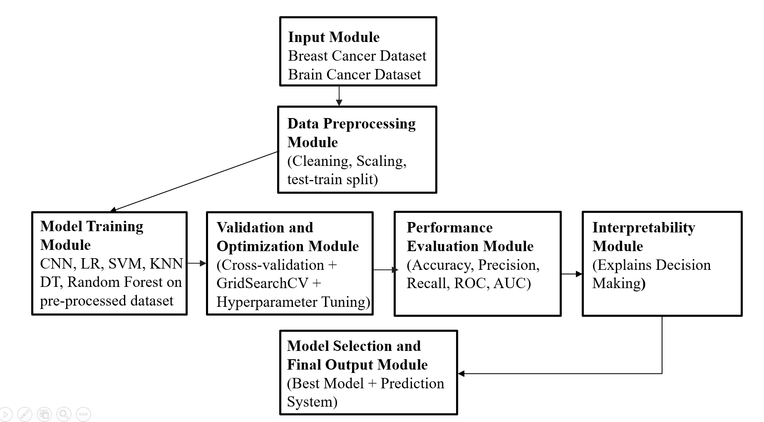
Fig 3.1.1: Module Connectivity
3.2 Analysis and Design through UML
The following diagram (Figure 3.2.1) demonstrates the class diagram of the proposed Tumor Sorting System, in terms of the static structure. This model shows how the classes are connected within the system through the use of attributes, methods and relation between the classes. The system structure, information flows, and relationship between the different aspects of the tumor dataset processing, model training, and performance evaluation can be comprehended easier with the assistance of the class diagram.
The type of user is the one who communicates with the system. Attributes of a user are userId and userName. The user procedures are uploadDataset() and viewResults that enable users to provide tumor dataset and see the final classification results with the best-performance model and its performance metrics. The class TumorDataset is interacted with by the user because the uploaded dataset is the most important key input into the system.
TumorDataset is the medical dataset that is presented by the user. It has the following properties: datasetId, filePath and datasettype. This class mainly loads the dataset using the loadDataset() method. The course is closely related to Preprocessor as the first step in processing the raw tumor data is the essential preprocessing, which makes the input ready to be used, to train the ML models.
Class Preprocessor will be in charge of data cleaning and preparation. Its functions are handleMissingValues, normalizeFeatures and stratifiedSplit. These functions process the raw dataset into a clean and normalized dataset which is suitably divided. The Preprocessor ensures a balanced and fair base of all subsequent models training by eliminating inconsistencies and scaling the features using StandardScaler.
Class LogisticRegression is a linear baseline classifier. It employs a sigmoid curve to find the likelihood of a tumor being benign or malignant. Its train() and predict() methods train binary and have interpretable feature coefficients which can be compared with more sophisticated models.
SVM (class SVM) is a classification technique with margins. It uses high-dimensional feature space to identify a best hyperplane that classifies tumors. The two functions train and predict are used to classify using the kernel, and hyperparameter optimization is used to optimize the regulation parameter, C, and the option of kernel to achieve the best classification results.
Class KNN does the distance-based classification that assigns class labels based on the majority vote of the nearest neighbors in the feature space. Its training and prediction functions are also sensitive to scaling the features and the normalization step in the Preprocessor is particularly critical to this model.
Class DecisionTree builds a hierarchical tree of rules based on thresholds of features to identify benign and malignant tumors. Its predict() and train() functions generate a model that is easily interpretable and it overfits easily unless depth constraints are enforced.
Class RandomForest is an ensemble learning model which takes a combination of many decision trees in a bagging method to enhance stability in classification and minimize overfitting. Also, it provides the method predict besides train, allowing it to get FeatureImportance, thus identifying the most influential tumor attributes in making classification decisions.
All the trained models are combined in the ModelSet class. ModelSet stores trainedModels, modelNames, predictions, crossValScores, and offers a consistent view of the trained state of the system. This provides a full depiction of the classification pipeline and is the key input of the downstream evaluation and optimization modules.
Class ValidationOptimizer improves the accuracy of the models using applyKFoldCV() and optimizeHyperparameters(). Five-fold cross-validation ensures that there is consistency in the accuracy result obtained, and it does not depend on one particular train-test split. Both the SVM and RandomForest models undergo hyperparameter tuning using GridSearchCV.
The class performance evaluator mentioned above could be used for measuring the performance of these models through techniques such as computeMetrics(), plotConfusionMatrix, and plotROCCurve. Accuracy, precision, recall, and F1-measure are among the metrics used to evaluate these models' performances. The role of a confusion matrix in this case is to reduce the rate of false negatives concerning the identification of cancer. In essence, it implies that even when the existence of cancer in the human body is considered to be benign, it is still very dangerous since it was not detected.
The Result object is kept in the Result class. The attributes of the Result class are bestModel, accuracyScores, rocAucScore, and featureImportance that together comprise an entire object consisting of all the results obtained from analysis. The class diagram displays the functioning of the tumor classification system as a programmatic pipeline. Once the dataset is uploaded, there follows the preprocessing, training of models, cross validation, testing, and model selection phases. Every single class handles a particular phase and thus ensures that the system is scalable. In addition, alterations in the design can be made to the component without influencing the rest of the pipeline.
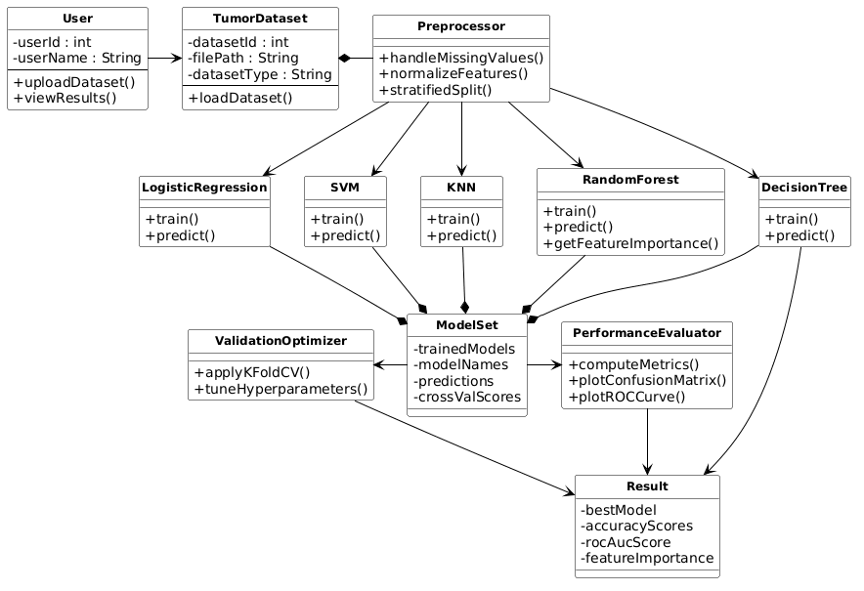
Fig 3.2.1: UML Diagram

SEQUENCE DIAGRAM
The following figure depicts the relationships among the different elements in the Tumor Classification System. This is the sequence of steps that occur when a user inputs tumor data and requests classification.
Input Phase: These stages begin with the introduction of the tumor data set into the system through upload by the user. The data set acts as the primary input, which is then passed to the data processing stage. The data set is uploaded into the system and sent to the preprocessing stage.
Preprocessing Phase: It is the stage at which the data is made ready to be used. This particular module will look into any missing values in the dataset, inconsistencies in data and normalization of the data by methods such as StandardScaler. The reason for this process is to have uniform features that could be easily understood by machine learning models.
Model Training Phase: The data after processing is then sent to the module for training the models. Several machine learning models like logistic regression, SVM, KNN, decision tree, and random forest are employed here. All models are trained using the same dataset. This ensures a fair comparison between the models. This stage helps in extracting trends from the features of the tumor.
Validation and Optimization Phase: The trained models are then passed on to the validation module. In this step, the use of 5-fold cross-validation is employed to validate the models. It also performs hyperparameter tuning based on GridSearchCV to enhance the performance of the model. This helps in reducing overfitting and improves generalization.
Performance Evaluation Phase: These models are tested against several measures of performance. Accuracy, Precision, Recall, and F1-Score are calculated using the evaluation function. The confusion matrix is generated to analyze classification errors. Moreover, ROC curves are plotted to evaluate the performance of the model. This stage will ensure that all the models are compared thoroughly.
Error Analysis Phase: The next step involves error analysis in the erroneous
classification where the malignant tumors may be classified as benign. It is essential in the medical field due to its direct effect on the reliability of diagnosis. It considers the reasons for these errors that may include overlaps in the feature
value and the constraint imposed by the dataset size.
Model Selection Phase: After evaluating the models, the system proceeds to the
model selection phase. This is the phase where the performance measures are fed
into the model selection component to determine which of the models performs better based on their respective recall and stability. A good model minimizes the occurrence of critical errors.
Result Generation Phase: The last steps towards determining the tumor
classification outcome is done by the model. The output would then be classified according to their class labels (Benign or Malignant) and also include performance measures like accuracy, precision, recall, F1-measure, and ROC-AUC score.
Output Stage: Lastly, in the output stage, the output will be shown to the user. The system presents the result of tumor classification, performance measures, and interpretations in an easy-to-understand manner.
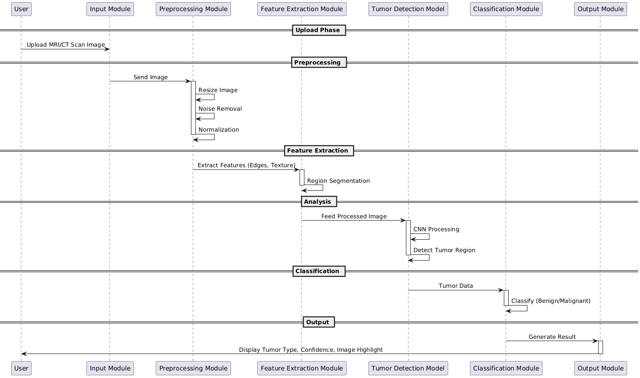
Fig 3.2.2: Sequence Diagram

USE CASE DIAGRAM:
In this particular study, the focus of this study will be on the creation of a system known as the “tumor classification system”, where the individual will be able to classify the tumor as being benign or malignant with the help of the use of machine learning algorithms.
The primary user of this system will be someone who wants to categorize tumor data without having to go through the medical characteristics in detail. Such a user may be a medical professional looking for quick diagnosis services, a researcher working on tumor data, or even a student handling medical data.
This is due to the use of the application that begins with the feeding of the tumor database into the software. The database contains several characteristics including numerical values such as tumor radius, texture, perimeter, and area. Once the database is loaded into the software, the analysis process takes place immediately.
The first phase involves the preprocessing of the data, such as cleaning the missing values, detecting any inconsistencies, and normalizing the features to make sure that consistency is attained. The system uses various ML algorithms like Decision Tree, K-Nearest Neighbors, Logistic Regression, Support Vector Machine, and Random Forest to analyze the data after preprocessing it. During the training and evaluation of the models is done the system computes different performance measures such as accuracy, precision, recall, and F1-score. It also creates confusion matrices and ROC curves to improve the understanding of model performance and find possible errors, particularly false negatives on detecting malignant tumors.
After the evaluation of the models, the system creates the most performing model on the basis of balanced metrics. The ultimate outcomes are the estimated tumor (benign or malignant), performance, and understanding of how the models behave.
Besides classification, the system is also interpretable and reveals the key characteristics of tumors that affect the prediction. This makes the users know how the model has come to make a choice.
It is also possible to consider an admin position within the system. The admin will take care of the dataset and as time passes, update the machine learning models and enhance system performance.
Finally, the case study illustrates how the Tumor Classification System can be used to analyze tumors in an efficient, accurate, and automated way. It minimizes the workload of a person, enhances reliability, and assists data-driven decision-making in medical use.
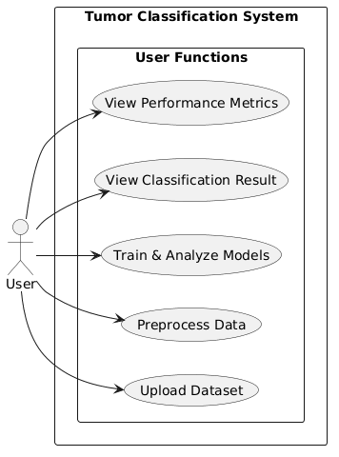
Fig 3.2.3: Use Case Diagram
ACTIVITY DIAGRAM
The activity diagram depicts the entire workflow of Tumor Classification System, and all the steps and decision points in the published analysis of tumor data. It will also assist in understanding the analysis that the system does on the data input, the analysis done on the data, and finally producing the output data.
It will help in describing how the system works. The start node shows where the system begins operating and starts once the dataset about the tumor is loaded. Input processing node gets the input and tests if the input is correct.
Data Preprocessing Stage: Once the input data has been validated, the next step in the process is the pre-processing phase, which is required to get the data ready for use. In this stage, missing data is handled, inconsistent data is dropped, and all the features are normalized using packages such as StandardScaler.
Parallel Draining and X-ray Training and Analysis: Parallel branches of workflow can be generated in abundance after preprocessing, in which different machine learning models operate simultaneously. These models include Logistic Regression, SVM, KNN, Decision Trees and random Forests among others.
Both models are able to learn tumor patterns/data individually and classify. Meanwhile, all models have performance metrics that include accuracy, precision, recall and F1-score computed. This parallel processing optimizes performance and enables a reasonable basis of comparisons between different algorithms.
Error Analysis and Evaluation: Once all the classifiers have predicted the data, an analysis is performed. Analysis of the predictions by the classification algorithm is performed using confusion matrix techniques, with particular emphasis on false negatives (incorrectly classified malignant tumors). The ROC curve as well as the AUC score is determined.
Feature Integration: Once the models have been evaluated, the outcomes from each model are going to be merged into a single feature set that includes measures of the performance of the models as well as the errors made. This will help ensure that all information is available in one place.
Model Selection Phase: It then goes ahead to choose the best performing model. The choice is made based on equally valued measures; nonetheless, emphasis is placed on accuracy and reliability to prevent any catastrophic mistakes in the diagnosis of any disease.
Result Generation: Once the optimum model is selected, the final classification output is obtained from the model itself. The output from the model determines the predicted tumor class – be it benign or malignant, and the evaluation measures are accuracy, precision, recall, F1-score, and ROC-AUC.
Output Phase: Furthermore, the results obtained at the end will be represented in an efficient and comprehensible manner for the user. This output is made up of data that concerns classification, performance, and behavior of the model.
End denotes the end of the whole process. Conclusion In summary, the above process is highly efficient since it employs multiple machine learning techniques to get the required tumor classification results through parallel processing techniques.
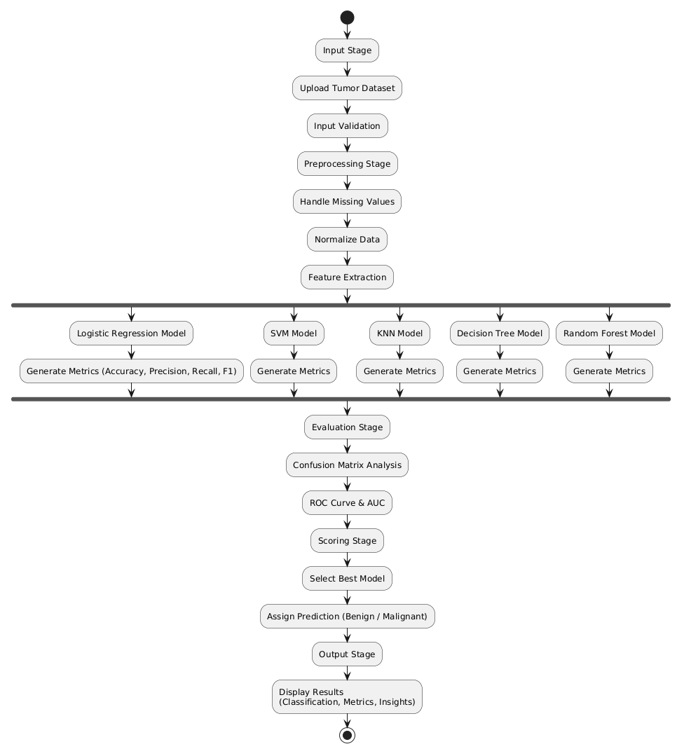
Fig 3.2.4: Activity Diagram
3.3 Requirements Engineering
Functional Requirements:
Dataset Upload / INP: The system will allow users to submit information
regarding tumors in standardized forms (such as CSV). The system will then verify
the data to ensure that it is correct and complete before continuing.
Data Preprocessing: The data would be preprocessed by the system, which includes operations such as applying functions akin to paint on the missing values, cleaning of the data from any inconsistencies, and normalization of the data through techniques such as StandardScaler.
Feature Handling: This is then followed by the algorithm segmenting the data into y which represents the labels and X, which represents the feature set. This ensures that the feature set is properly scaled for training purposes.
Model Training: For the classification of tumor types, this project will employ various machine learning techniques that include Logistic Regression, Support Vector Machines (SVM), K-Nearest Neighbor (KNN), Decision Trees, and Random Forest techniques.
Validation and Optimization: Techniques such as cross validation that will be applied in the system (5-folds cross-validation) to ensure accuracy of the model. The system will optimize the hyperparameters using the GridSearchCV for improving the model performance.
Performance Evaluation: All models will be evaluated by their respective performance parameters such as Accuracy, Precision, Recall, and F1 Score. The system will generate confusion matrices and ROC curves for evaluating their classification performance.
Error Analysis: The model will be used for examining misclassification, in particular, false negatives, whereby cancerous growths are incorrectly classified as benign. It may help determine some of the reasons behind such instances of misclassification.
Model Selection: The system would be capable of selecting the model with the best performance based on balanced evaluation metrics, thus delivering reliable results in terms of accuracy in medical diagnoses.
Result Generation: The system generates the final output for the classification of the tumor (whether Benign or Malignant) along with other metrics to evaluate its performance.
Visualization/Output Display: The output shall be made available in an organized and simple format containing information on classification, performance measurement, and analysis with insights that can easily be interpreted.

Non-Functional Requirements
Performance: The system should scan through the tumor data and classify it effectively and within an acceptable period.
Scalability: It is expected that the system will have capabilities to handle large data sets and different types of classification functions without affecting its performance.
Accuracy and Reliability: Accuracy and precision during tumor classification need to be ensured with proper training in machine learning algorithms.
Usability: The system should have a user-friendly interface that enables data uploading and explanation easily.
Explainability: In order to increase the transparency of the system, it is necessary to provide some insights about model decisions like feature importance and performance evaluation.
Robustness: The system should have the capability to handle missing and noisy data but still produce valid results.
Modularity: The system must use a modular architecture for its preprocess, train, evaluate, and output modules to make them more maintainable.
Compatibility: The system should be able to accept popular data formats (such as CSV) and operate on any computing platform.
Security: The system should include a prescription that no one else can access the information loaded into it.
Maintainability: The system must provide easy modifications of models, datasets and algorithms to enhance performance as time goes by.

3.4 Software and Hardware Requirements
Table 3.4.1: Software and Hardware Requirements
Software Requirement | Hardware Requirement
Operating System (OS): Windows 10 / 11 / Linux / macOS | Processors: Intel i5 / i7 or Ryzen 5 / 7 or higher
Programming Language: Python 3.8 or higher | RAM: Minimum 8 GB (Recommended 16 GB)
Frontend (Optional): HTML, CSS, Streamlit / Flask | Storage: Min 10 GB free space (SSD recommended)
Libraries: Scikit-learn, Pandas, NumPy, Matplotlib, Seaborn | Optional: GPU not required (can be used for faster computation)

Software and Hardware Description
Tumor Classification System is Python-based because it is very supportive of machine learning and data analysis. Classification models are implemented in libraries like Scikit-learn, whereas preprocessing of data is done using Pandas and NumPy. Visualization is supported with Matplotlib and Seaborn, a basic user interface can be provided using optional frameworks such as Streamlit or Flask.
The system is capable of working well with a conventional computer with an Intel i5/Ryzen 5 processor, minimum of 8 GB (maximum 16 GB) of memory, and about 10 GB of free storage. Given that the project is based on classical machine learning on structured data, there is no need to have a GPU, although it can be optional to speed up the process.

CHAPTER 4

RESULTS AND DISCUSSION

4.1 Description about Dataset
The projected Tumor Classification System is based on the Breast Cancer Wisconsin (Diagnostic) Dataset, one of the most widespread medical datasets in ML studies. It is publicly accessible and comprises of well-organised numerical information obtained out of digitized pictures of breast tumor samples.
System 569 examples of tumor samples, including 357 benign and 212 malignant. Each sample is characterised by 30 numerical features which are representative of different aspects of the tumour, including radius, texture, perimeter, area, evenness, density, concaveness, regularity and fractal dimension. These values are calculated as the mean, standard error and worst-case of each tumor.
This data set is highly structured as compared to the unstructured medical report; hence is suited to the usage of classical ML algorithms. The numerical characteristics of the data enable effective preprocessing, such as normalization and feature scaling, one of which are obligatory in models such as SVM and KNN.
What is significant with the dataset is that it is clean and well balanced with few missing values which has assisted it in obtaining credible model performances. The dataset also represents actual diagnostic situations in the real world when a tumor classification will be conducted on the basis of measurable features, which are taken out of biopsy images.
The feature in question in the dataset consists of two types:
0 = Benign (non-malignant)
1 = Malignant (cancerous)
In such a way, the problem becomes a binary classification task that aims at distinguishing between benign and malignant data instances.

All in all, it can be said that the provided set can become a good foundation for working with machine learning algorithms. In such a way, this system helps classify tumors, making it possible to make relevant medical decisions due to the structure, the importance, and relevance of data.
4.2 A Comprehensive explanation about the Experimental Results
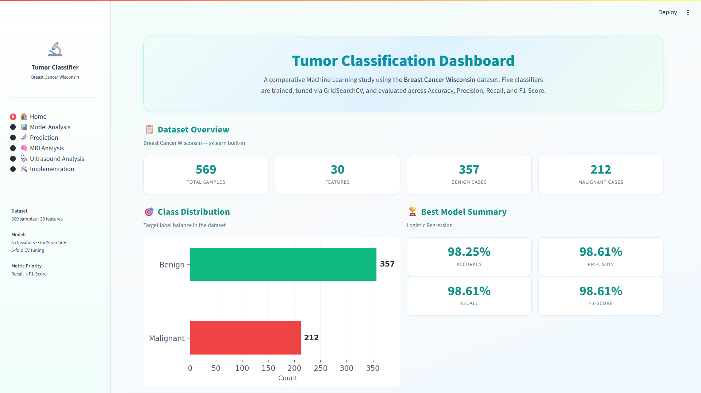
Fig 4.2.1: Dashboard

Above is the Dashboard Page for the Tumor Classification System which acts as a single window for analysis and comparison of the performance of machine learning models. It displays the information about the data set, classification results, and performance measures in tabular form, thus making it easy to evaluate the performance of different models used in tumor classification.
At the top of the dashboard, there is a brief overview of the entire system in form of the description showing that different machine learning algorithms are being developed and optimized using the GridSearchCV method. The key metrics that are utilized to measure performance of different models include Accuracy, Precision, Recall and F1-Score that help users understand the entire evaluation process.
This part provides a brief insight on the statistics of the data set including sample size, number of attributes and the number of benign and malignant cases. The overview makes users understand the characteristics of the dataset they have created for training their model.
An Example of Class Distribution
This is a graphical representation that shows how the class distribution of tumors is displayed using a bar graph. This allows one to determine the balance between benign and malignant samples, which is necessary for making sure the model behaves fairly.
Best Model Summary gives information about the best performing model based on evaluation metrics. In the current case, the most performing model is the Logistic Regression model that boasts high scores for Accuracy, Precision, Recall, and F1 Score. All evaluation metrics have been presented in a simplified manner, making it easy to determine its performance.
There are also other options of navigation in the sidebar like Home, Model Analysis, Prediction, MRI Analysis, Ultrasound Analysis, Implementation. These features improve usability because they enable users to search the various elements of the system making the dashboard user-friendly and informative to study and make decisions.

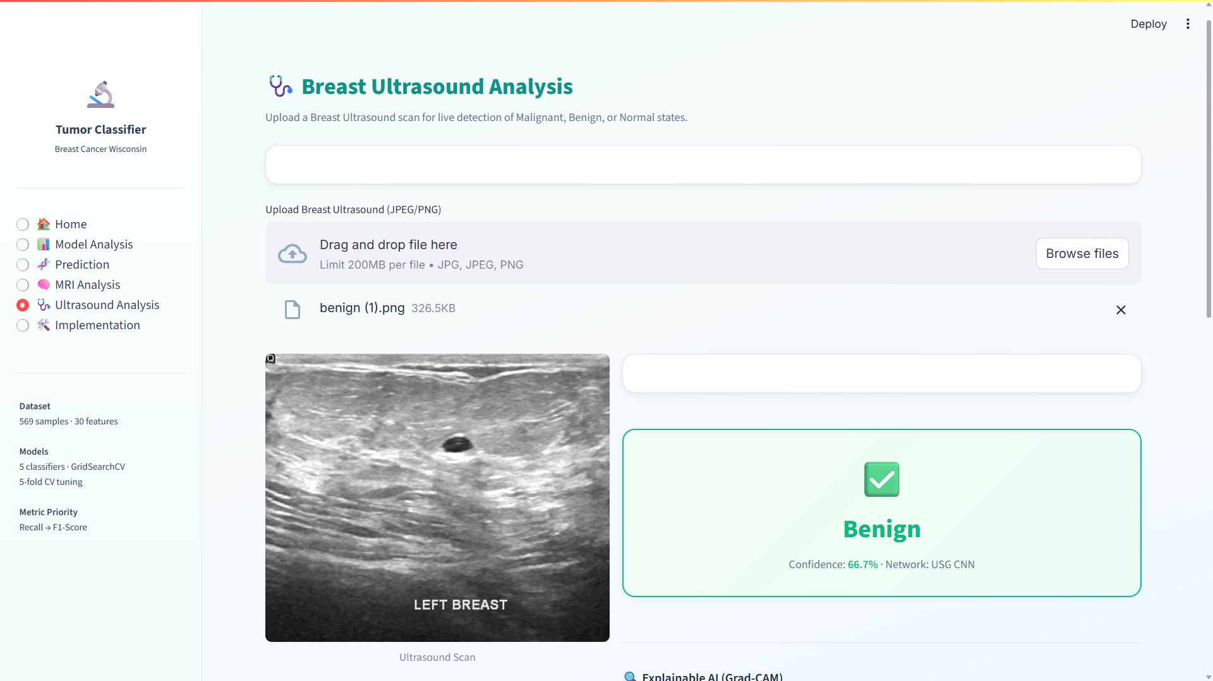
Fig 4.2.2: Ultrasound Analysis
The above picture shows the Breast Ultrasound Analysis Page of the Tumor Classification System offering an interface to study ultrasound images and foretell the tumor conditions. The module allows users to post the breast ultrasound scans and obtain automatic predictions on whether the tumor is benign, malignant, or normal.
There was a brief description at the very beginning of the page, and its goal was to classify images using real-time images, with a focus on image classification. The system is compatible with most popular image formats like JPG, JPEG, and PNG, so the users can easily upload ultrasound scans.
Once the image has been processed, the system thinks with the help of a trained CNN model and creates the predictions. The result is presented visually in a section that is highlighted and the word output represents the predicted class, which in this case, is Benign, followed by a score in terms of confidence, which is the level of confidence the model has.
In general, this page shows that the system processes medical images along with machine learning to provide an effective and quick tumor classification. It offers simple analysis in complex and easy to understand format that can be applied to learn and apply.
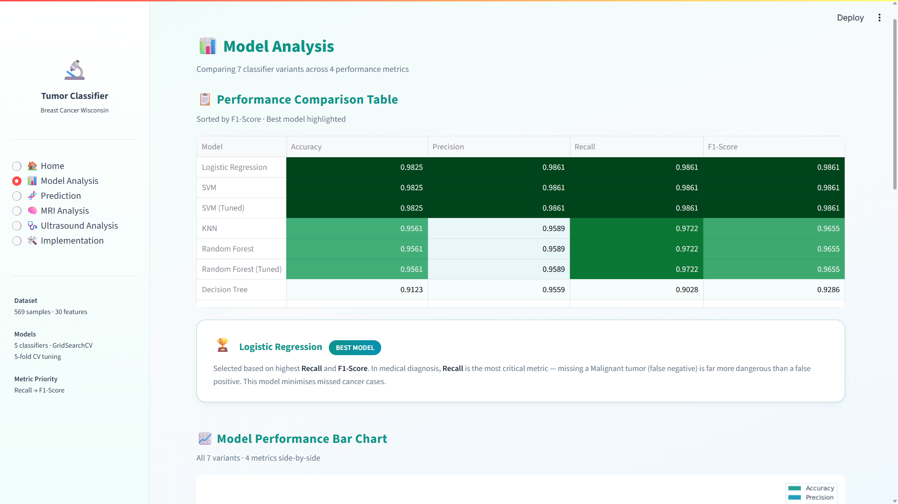
Fig 4.2.3: Model Analysis

The Figure above shows the Model Analysis Page of the Tumor Classification System, where you will find a more detailed comparison of the several ML models that can be used to classify tumors. This page helps users evaluate and understand the performance of different classifiers based on various evaluation metrics.
The top description outlines briefly that a number of versions of the classifier are compared based on the key measures of Performance in relations of Accuracy, Precision, Recall, and F1-Score. The Performance Comparison Table shows all these metrics in each model and enables the user to readily compare the effectiveness of each model. It is sorted according to F1-Score and the most successful model is visually indicated in order to be identified more easily.
Based on the comparison, models like the Logistic Regression and the SVM obtain the best performance, and the scores are constant and high in all the measures. Models such as Decision Tree, in contrast, demonstrate relatively poorer performance suggesting the potential of overfitting or incapability to process the data. This comparison aids users to clearly establish the most reliable models that can be used to classify tumors.
The Best Model Summary section has mentioned the Logistic Regression as the best working model. It states that the choice is made on the factors of higher Recall and F1-Score which are important when making a diagnosis in medicine. Because the consequences of a false negative (a malignant tumor) can be severe, it is better to have a more safer and more reliable prediction which is guaranteed by Recall.
Also, there is a page consisting of a Model Performance Bar Chart, that clearly illustrates the presentation of all the models in several metrics. With such a graphic representation, it is easier to discern changes between models and this leads to easier decision-making. On the whole, this page offers a detailed and easy to use discussion of model performance, assisting to a user in choosing the most appropriate model to use in tumor classification.

4.3 Importance of the Proposed Work with its Benefits

The proposed Tumour Detection System is particularly important because it offers an AI-based model of early detection and classification of tumours based on medical imaging data. In the current healthcare system, proper and timely diagnosis is a very important aspect in enhancing the survival rate of the patient. Nevertheless, radiologists may take time, be subjective when analyzing MRI or CT scan images manually, and may vary when analyzing faint tumour patterns. The offered system will solve these problems by combining the image preprocessing, feature extraction, deep-learning-based classification (including CNN models), tumour segmentation, and explainable AI methods into a single platform to increase the accuracy and efficiency of analytical outcomes.
One of the main importance of this system is that it helps medical workers in diagnosing tumours at an early stage more accurately. The system helps to decrease the possibility of misdiagnosis and helps faster clinical decisions making by automatically identifying the presence of abnormal areas in medical pictures, categorising them as tumour types, and pointing out where affected areas are. This is especially useful in busy healthcare settings with high workload in which high-volume imaging data must undergo rapid and precise analysis.
The system has a number of benefits in real-life healthcare practice. It not only saves much work on radiologists since the arduous work of analyzing images is automated, but also enhances uniformity in diagnosis by reducing the number of human mistakes and provides objective assessment of the medical images. Moreover, it can be noted that the implementation of visualization and explainability modules will enable doctors to learn the logic behind predictions, which will enhance the trust in AI-assisted diagnosis. The system will also be able to assist in comparative analysis between patient scans to allow improved tracking of tumour growth or response to treatment over time.
The second significant benefit is that it can transform complicated deep learning outputs into an easy-to-understand user interface, thus it is not only accessible to specialists but also to general practitioners. This enhances access to higher-order diagnostic instruments in a resource-constrained environment where highly trained radiologists are not necessarily accessible. Moreover, the system can be expanded to multi-modal data (i.e. integration of imaging with clinical records) which increases its functionality in terms of overall medical evaluation.
All in all the proposed Tumour Detection System improves the accuracy, speed, and reliability of the medical diagnosis. It helps to achieve good results, promotes the provision of quality health care, and stimulates the use of intelligent decision support systems, hence its great utility in practical application of medicine.

4.4 Limitations of the Proposed Work
The quality of input images such as MRI/CT images plays a vital role in the effectiveness of proposed work. Low-quality input images, low-resolution images, and noisy images can reduce the effectiveness of the proposed method considerably.
Variability due to different imaging techniques, scanning processes, and quality of hospitals affects the generalization capability of the proposed algorithm..
The model might not be able to detect very small tumours or early-stage tumours especially where contrast between normal and abnormal tissue is low.
Complex cases, where there are overlapping tissues or unusual shapes of tumours, can give erroneous results of segmentation or classification.
Deep learning model consumes a great deal of medical data that is labeled. Small or unbalanced datasets may decrease the reliability of prediction and augment bias.
The system can give false positives (when there is no tumour in a patient, it identifies the tumour) or false negatives (when a patient does have a tumour, the system fails to detect it), which can affect clinical decision-making.
Explainability methods give information on the model decisions, which might not necessarily be aligned with medical reasoning causing trust issues among medical practitioners.
This system mainly emphasizes imaging information and might not include the other significant clinical variables including patient history, laboratory reports, and genetic data.
The large computational needs to train and process large medical images can elevate the cost of the system and reduce the possibility of implementation in real-time and resource-constrained settings.
Connection with already installed hospital systems (there could be PACS or electronic health records) might be complicated and could need extra infrastructure.
The system might also struggle to cope with the rare tumour types or other unusual medical conditions as there is little training examples.
The diagnosis cannot be completely autonomous; it is supposed to be a decision-support system, which still needs to be verified by the medical community.

CHAPTER 5

CONCLUSION AND FUTURE ENHANCEMENTS

5.1 CONCLUSION
Overview of the Project.
The Tumour Detection System is a smart healthcare solution that will help accurately and efficiently identify tumours on medical images of any type, be it MRI or CT scan. This project is aimed at enhancing diagnostic reliability through application of superior deep learning methods to detect abnormal growths in the human body. The system processes medical images, points out suspicious areas, and presents the results of classification that can assist in establishing the existence and type of tumour. It is a helpful device to medical practitioners and saves on the manual work and enhances medical diagnosis speed.
Objectives
The ultimate goal of the Tumour Detection System is to develop a highly effective model that will be able to perform analysis of medical images and detect tumors in the most accurate way possible. The system is supposed to categorise tumours into various groups (benign or malignant), divide the affected areas, and help the doctors to know the extent of the condition. It is also concerned with enhancing early detection, which is paramount in the treatment. The system also gives visual outputs and confidence scores to aid clinical decision making and improve diagnostic clarity.
Importance
As the number of cancer cases is constantly rising globally, there is high demand in the valuable and rapid diagnostic tools. The process of analyzing medical images manually can consume a lot of time and thus can depend on the experience of the radiologist. The Tumour Detection System is significant as it enhances to minimise diagnostic delays, human error, and provides uniform assessment of medical images. It may be particularly helpful in those regions, where there is a lack of skilled medical workers, and thus the quality of the medical services may be enhanced.

Significance
The importance of the Tumour Detection System is that it combines various AI methods into one system. It involves preprocessing of images, feature extraction, deep learning-based classification, and visualization to provide accurate results. The system improves transparency as it generates explainable outputs that demonstrate the way predictions are approached. The system can convert the complex outputs of the models into visual insights which can be understood, making it practical and useful in the real world clinical setting. AI technology that bridges the gap between high-end technology and routine healthcare practice.
Approach Chosen
The Tumour Detection System is designed in a way such that it follows a certain approach. Preprocessing is done in order to remove any form of noise present in the medical image. Then, using machine learning techniques such as CNNs, feature extraction and classification is done. Tumour detection techniques are used for highlighting the tumoured regions of the affected area. The model will provide the results along with their confidence score.
Qualitative Results
The system is able to identify the tumour sites as well as highlight abnormality spots and also highlight the important parts of the images. This system presents visual feedback that can help the doctors understand where the tumours are and their nature. These results make it easier for the analysis of the complicated medical information. The system makes pattern identification easy as well as helps in comparing different scans and acquiring information about the tumors.
Quantitative Results
From the findings, the Tumour Detection System is quite effective in terms of accuracy, precision, and recall with regards to its role in detecting tumours. Algorithms used for deep learning purposes within the system give consistent and accurate predictions for various data sets. In general, the findings reveal that this system can be helpful when it comes to medical diagnosis as well.

5.2 Future improvements
This proposed artificial intelligence-based Tumour Detection System proves to be efficient and effective in analyzing medical images; however, there are many points that could be improved upon in order to make this system even more powerful and practical.

Improvement of Data Integration
Multi-source medical data integration is one of the significant improvements. The system is currently mostly based on imaging data (MRI or CT scans). This can be done through incorporating the medical history of the patient, laboratory results, biopsy results, as well as the genetic make-up in the future. With this, it would be possible to analyze everything effectively, improving the process of diagnosing.
Advanced Multimodal Analysis
It is possible to enhance the system with the help of multimodal data analysis whereby various inputs of medical data are combined. For example, the combination of radiology images and pathology slides or patient records may assist in the process of getting a better knowledge about tumour features. It will be important to apply computer vision and natural language processing technologies to enable the system to analyze complex information.
Improvement in Model Accuracy.
Future directions can be based on more complex deep learning models like hybrid CNN models, transformer-based models, or ensemble methods. The bigger and more varied datasets will aid in training that will enhance generalization and minimize bias. Mechanisms of continuing learning can also be provided to ensure that the model changes with time as it receives new information.
Real-Time Processing Capability
It is possible to improve the system to accommodate real-time tumour detection and tracking. It can also analyze scans in real-time as they are being produced by connecting with hospital imaging systems. This will assist physicians to make decisions quicker, particularly in the emergency cases, where diagnosis is very important.
Improved Explainability
Despite the fact that the system has visual outputs, the future versions can also be equipped with more sophisticated explainable AI methods. These improvements will be a clear indication of why a specific prediction was chosen, allowing important areas and aspects of the image to be pointed out. This will enhance confidence and embrace within medical professionals.
Scalability and Deployment Optimization.
The system needs to be optimized to be deployed in cloud and edge environments to make it widely usable. This will enable it to deal with volumes of medical data effectively and assist a number of hospitals or diagnostic centers at the same time. One of the priorities will be to reduce the computational cost without impacting on the performance.
Domain-Specific Knowledge.
Medical guidelines, clinical protocols, and expertise can be incorporated into the system to enhance it. This will assist in making sure that predictions are compatible with the standard diagnosis and enhance reliability of the system in clinics.
Expansion to Multiple Diseases.
The system is currently focused on the detection of tumours, but can be extended to detect other diseases including cysts, lesions or neurological conditions. This will make it a more all-inclusive diagnostic instrument.
Plugging into Healthcare Systems.
The system can be connected to hospital management system including Electronic Health Records (EHR) and Picture Archiving and Communication Systems (PACS). This will facilitate workflow and help healthcare professionals to use and access the system.
In general, Tumour Detection System has a great potential to be developed further. It can become a highly reliable and intelligent clinical decision-support system that can greatly improve healthcare outcomes by integrating updated technologies, increasing the number of sources of data, and ensuring usability.

CHAPTER 6
REFERENCES

[1] O. Ronneberger, P. Fischer, and T. Brox, “U-Net: Convolutional Networks for Biomedical Image Segmentation,” Medical Image Computing and Computer-Assisted Intervention (MICCAI), pp. 234–241, 2015.
[2] K. Simonyan and A. Zisserman, “Very Deep Convolutional Networks for Large-Scale Image Recognition,” arXiv preprint arXiv:1409.1556, 2014.
[3] A. Krizhevsky, I. Sutskever, and G. E. Hinton, “ImageNet Classification with Deep Convolutional Neural Networks,” Advances in Neural Information Processing Systems, vol. 25, 2012.
[4] G. Litjens, T. Kooi, B. E. Bejnordi, et al., “A Survey on Deep Learning in Medical Image Analysis,” Medical Image Analysis, vol. 42, pp. 60–88, 2017.
[5] S. Pereira, A. Pinto, V. Alves, and C. A. Silva, “Brain Tumor Segmentation Using Convolutional Neural Networks in MRI Images,” IEEE Transactions on Medical Imaging, vol. 35, no. 5, pp. 1240–1251, 2016.
[6] N. Codella, D. Gutman, M. Celebi, et al., “Skin Lesion Analysis Toward Melanoma Detection: A Challenge at ISIC,” IEEE Journal of Biomedical and Health Informatics, vol. 23, no. 2, pp. 547–553, 2019.
[7] H. Greenspan, B. van Ginneken, and R. M. Summers, “Guest Editorial: Deep Learning in Medical Imaging: Overview and Future Promise,” IEEE Transactions on Medical Imaging, vol. 35, no. 5, pp. 1153–1159, 2016.
[8] J. Arevalo, F. A. González, R. Ramos-Pollán, J. L. Oliveira, and M. A. Guevara Lopez, “Representation Learning for Mammography Mass Lesion Classification with Convolutional Neural Networks,” Computer Methods and Programs in Biomedicine, vol. 127, pp. 248–257, 2016.
[9] D. Shen, G. Wu, and H. Suk, “Deep Learning in Medical Image Analysis,” Annual Review of Biomedical Engineering, vol. 19, pp. 221–248, 2017.
[10] M. Havaei, A. Davy, D. Warde-Farley, et al., “Brain Tumor Segmentation with Deep Neural Networks,” Medical Image Analysis, vol. 35, pp. 18–31, 2017.
[11] Y. LeCun, Y. Bengio, and G. Hinton, “Deep Learning,” Nature, vol. 521, pp. 436–444, 2015.
[12] T. Chen and C. Guestrin, “XGBoost: A Scalable Tree Boosting System,” Proceedings of the 22nd ACM SIGKDD, pp. 785–794, 2016.
[13] L. Breiman, “Random Forests,” Machine Learning, vol. 45, no. 1, pp. 5–32, 2001.
[14] C. Cortes and V. Vapnik, “Support-Vector Networks,” Machine Learning, vol. 20, no. 3, pp. 273–297, 1995.
[15] T. Cover and P. Hart, “Nearest Neighbor Pattern Classification,” IEEE Transactions on Information Theory, vol. 13, no. 1, pp. 21–27, 1967.
[16] R. C. Gonzalez and R. E. Woods, “Digital Image Processing,” 4th ed., Pearson, 2018.
[17] S. Lundberg and S.-I. Lee, “A Unified Approach to Interpreting Model Predictions (SHAP),” Advances in Neural Information Processing Systems, vol. 30, 2017.
[18] M. T. Ribeiro, S. Singh, and C. Guestrin, “Why Should I Trust You? Explaining the Predictions of Any Classifier (LIME),” Proceedings of the 22nd ACM SIGKDD, pp. 1135–1144, 2016.
[19] F. Milletari, N. Navab, and S.-A. Ahmadi, “V-Net: Fully Convolutional Neural Networks for Volumetric Medical Image Segmentation,” 3DV Conference, pp. 565–571, 2016.
[20] I. Goodfellow, Y. Bengio, and A. Courville, “Deep Learning,” MIT Press, 2016.

CHAPTER 7

APPENDICES

1. Comparative ML Pipeline (tumor_classification.py)
import warnings
warnings.filterwarnings("ignore")
import numpy as np
import pandas as pd
import matplotlib
matplotlib.use("Agg")
import matplotlib.pyplot as plt
import seaborn as sns
import os

from sklearn.datasets import load_breast_cancer
from sklearn.model_selection import train_test_split, GridSearchCV, StratifiedKFold, cross_val_score
from sklearn.preprocessing import StandardScaler
from sklearn.metrics import (
accuracy_score, precision_score, recall_score, f1_score,
confusion_matrix, roc_curve, auc, classification_report
)
from sklearn.linear_model import LogisticRegression
from sklearn.svm import SVC
from sklearn.neighbors import KNeighborsClassifier
from sklearn.tree import DecisionTreeClassifier
from sklearn.ensemble import RandomForestClassifier

OUTPUT_DIR = "outputs"
os.makedirs(OUTPUT_DIR, exist_ok=True)

def load_and_prepare_data():
raw = load_breast_cancer()
df = pd.DataFrame(data=raw.data, columns=raw.feature_names)
df["target"] = raw.target
X = df.drop("target", axis=1)
y = df["target"]
return df, X, y, raw.feature_names, raw.target_names

def preprocess_data(X, y):
X_train, X_test, y_train, y_test = train_test_split(
X, y, test_size=0.20, random_state=42, stratify=y
)
scaler = StandardScaler()
X_train_sc = scaler.fit_transform(X_train)
X_test_sc = scaler.transform(X_test)
return X_train_sc, X_test_sc, y_train, y_test, scaler, X_train, X_test

def get_base_models():
return {
"Logistic Regression": LogisticRegression(max_iter=10000, random_state=42),
"SVM": SVC(probability=True, random_state=42),
"KNN": KNeighborsClassifier(),
"Decision Tree": DecisionTreeClassifier(random_state=42),
"Random Forest": RandomForestClassifier(random_state=42),
}

def tune_models(X_train, y_train):
cv = StratifiedKFold(n_splits=5, shuffle=True, random_state=42)
svm_params = {"C": [0.1, 1, 10, 100], "kernel": ["linear", "rbf"]}
svm_grid = GridSearchCV(SVC(probability=True, random_state=42), svm_params, cv=cv, scoring="f1", n_jobs=-1)
svm_grid.fit(X_train, y_train)

rf_params = {"n_estimators": [50, 100, 200], "max_depth": [None, 5, 10, 20]}
rf_grid = GridSearchCV(RandomForestClassifier(random_state=42), rf_params, cv=cv, scoring="f1", n_jobs=-1)
rf_grid.fit(X_train, y_train)

return {"SVM (Tuned)": svm_grid.best_estimator_, "Random Forest (Tuned)": rf_grid.best_estimator_}

def evaluate_model(model, X_train, X_test, y_train, y_test, name):
model.fit(X_train, y_train)
y_pred = model.predict(X_test)
return {
"Model": name,
"Accuracy": round(accuracy_score(y_test, y_pred), 4),
"Precision": round(precision_score(y_test, y_pred), 4),
"Recall": round(recall_score(y_test, y_pred), 4),
"F1-Score": round(f1_score(y_test, y_pred), 4),
}

def train_all_models(base_models, tuned_models, X_train, X_test, y_train, y_test):
all_models = {**base_models, **tuned_models}
results = []
for name, model in all_models.items():
metrics = evaluate_model(model, X_train, X_test, y_train, y_test, name)
results.append(metrics)
return pd.DataFrame(results).set_index("Model"), all_models

def plot_confusion_matrix(model, X_test, y_test, model_name, target_names):
y_pred = model.predict(X_test)
cm = confusion_matrix(y_test, y_pred)
fig, ax = plt.subplots(figsize=(7, 5))
sns.heatmap(cm, annot=True, fmt="d", cmap="Blues", xticklabels=target_names, yticklabels=target_names, ax=ax)
plt.savefig(os.path.join(OUTPUT_DIR, "confusion_matrix.png"))
plt.close()

def plot_roc_curve(model, X_test, y_test, model_name):
proba = model.predict_proba(X_test)[:, 1]
fpr, tpr, _ = roc_curve(y_test, proba)
roc_auc = auc(fpr, tpr)
plt.figure(figsize=(7, 5))
plt.plot(fpr, tpr, label=f"AUC = {roc_auc:.4f}")
plt.plot([0, 1], [0, 1], linestyle="--")
plt.savefig(os.path.join(OUTPUT_DIR, "roc_curve.png"))
plt.close()

def plot_feature_importance(all_models, feature_names, top_n=15):
rf_key = "Random Forest (Tuned)" if "Random Forest (Tuned)" in all_models else "Random Forest"
rf = all_models[rf_key]
importances = rf.feature_importances_
indices = np.argsort(importances)[::-1][:top_n]
feats = [feature_names[i] for i in indices]
plt.figure(figsize=(9, 6))
plt.barh(feats[::-1], importances[indices][::-1])
plt.savefig(os.path.join(OUTPUT_DIR, "feature_importance.png"))
plt.close()

def main():
df, X, y, feature_names, target_names = load_and_prepare_data()
X_tr, X_te, y_train, y_test, scaler, _, _ = preprocess_data(X, y)
tuned = tune_models(X_tr, y_train)
results_df, all_models = train_all_models(get_base_models(), tuned, X_tr, X_te, y_train, y_test)
best_name = results_df.sort_values(["F1-Score", "Recall"], ascending=False).index[0]
plot_confusion_matrix(all_models[best_name], X_te, y_test, best_name, target_names)
plot_roc_curve(all_models[best_name], X_te, y_test, best_name)
plot_feature_importance(all_models, feature_names)

if __name__ == "__main__":
main()

